Oracle database Administration Services
SOP_Database Shutdown

Submitted to



By



CIS, Wipro Limited

Document Details

Project Name | Innogy SE
Account | CIS
IT Component/Application Title | Database shutdown
Current Version | 1.2
List of Contributors | Abhishek Kansal , Balaji Ankalle, Sreya Puthukudy
Customer Contact Information

Version History
(All revisions made to this document must be listed in chronological order. All revisions must be approved. Review and Approval can be done by an internal source or by the customer)
Version | Date of Revision | Description | Author | Reviewed By | Approved By
1.0 | 05-03-2018 | Intial Draft | Abhishek Kansal | Balaji Ankalle | Yogesh Desai
1.1 | 20-03-2018 | Document Completed | Abhishek Kansal | Balaji Ankalle | Yogesh Desai
1.2 | 07-01-2019 | Updated the content | Sreya Puthukudy | Jiten Pansara | Santosh Badiger

Document Distribution List
S.No | Name and Company | Purpose
1 | RWEIT-ORACLEDBA | This document is about the steps of shutdown databases.
2

TABLE OF CONTENT
Purpose 4
1. Scope 5
2. Database Startup Shutdown Flow Process 5
3. Steps To Start/Shutdown Database 5
3.1 Connect To The Server 5
3.2 Check for backup \ job is running 6
3.3 Check for dependency of database with other database \ application 8
3.4 Database Shutdown 8
4. Reference 8

Purpose
This document is prepared for Startup & shutdown of oracle database and listener of Oracle Database Administration Services at RWE GBS UK.

Scope
This document is prepared for RWE GBS UK Wipro sustenance team and provides the concepts of for Startup & shutdown of oracle database and listener at Linux at RWE GBS UK.

Database Startup Shutdown Flow Process
The below sheet contains the flow for Database Startup Shutdown Flow Process:
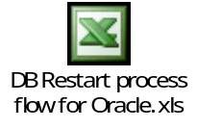
Note: The above flow is a draft. It is required to be modified on the customer discussion.

Steps To Start/Shutdown Database

Connect To The Server
Step 1: Double click on putty.exe

Step 2: Type the host name of the server and select telnet. Then press ok.

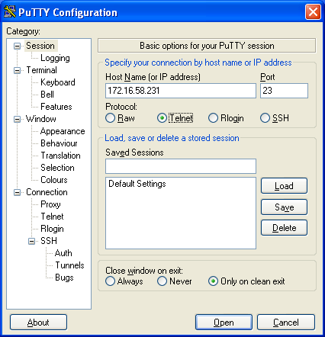

Step 3: It will ask for username and password. Give username and password.

Check for backup \ job is running
Refer the start time; end time and log file for checking the status of job execution.
3.3.1

select count(*),status from v$session where type='USER' group by status;
Execute the below query to check the users logged in.
SQL> select user#,username from v$session;

USER# USERNAME
---------- ------------------------------
0
0
0 SYS
0
0
0
0
0
0
0
0

USER# USERNAME
---------- ------------------------------
0
0
0

14 rows selected.

--> Kill the Inactive and Active sessions.

Kill session

Make the spool for kill the all session

spool kill.sql

SELECT 'ALTER SYSTEM KILL SESSION '||''''||sid ||','|| serial#||''''||' immediate;'
FROM v$session
WHERE status ='INACTIVE'

spool off

3.2.4
Check for any active sessions and kill them as well at OS level post identifying the PID

# ps -ef | grep LOCAL=NO | grep $ORACLE_SID
# kill -9 PID

Check for dependency of database with other database \ application
Refer the Application Database Dependency for same.

Database Shutdown
SQL> alter system checkpoint ;
SQL> alter system switch logfile;
SQL> shut immediate --> Monitor the Alert Log

Stopping the database

SQL>shutdown immediate
Database Closed
Database Dismounted
ORACLE instance shut down

LISTENER Shut Down
$ lsnrctl
$ lsnrctl>stop LISTENER

Reference
- http://www.dba-oracle.com/concepts/db_startup_shutdown.htm

